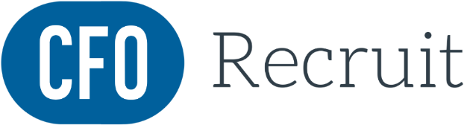

AI-Powered Interview Preparation Guide
Use the prompts below with your preferred AI assistant to build a powerful, personalized interview preparation pack. Each section explains what to upload and what you will receive in return.
How to Use This Guide
• Copy the prompts exactly as written into your chosen AI tool.
• Attach the relevant documents where indicated, your resume and the job description
• Work through each section in order for the most complete preparation.

SECTION 1 | Core Interview Prep Prompts
Use these prompts inside your preferred AI tool. Attach your resume and the job description as files before sending each prompt.
Prompt 1 Competency-Based Interview Questions
What to attach: Job description
Copy and send this prompt:
Create several competency-based interview questions for the attached job description.

Prompt 2A STAR Model Answers
What to attach: Job description + your resume
Copy and send this prompt:
Using these interview questions and my resume attached, prepare some model answers to these questions using the STAR technique.

Prompt 2B Mock Interview Script
What to attach: Job description
Copy and send this prompt:
Create a mock interview script based on this role.

Prompt 3 Knowledge Gap Analysis & Probing Questions
What to attach: Job description + your resume
Copy and send this prompt:
Highlight any knowledge gaps in my resume or ask me some further probing questions to test me regarding these gaps.

SECTION 2 | Advanced Strategic Prompts
Use these prompts inside your chosen AI tool. Attach your resume and the job description before sending each prompt.
Prompt 1 Resume Highlights Using STAR
What to attach: Job description + your resume
Copy and send this prompt:
I am being interviewed for the attached job description and if I am asked to run through my resume (see attached), please prepare some highlights I should raise. Use the STAR technique.

Prompt 2 Knowledge Gap Analysis & Probing Questions
What to attach: Job description + your resume
Copy and send this prompt:
Highlight any knowledge gaps in my resume or ask me some further probing questions to test me regarding these gaps.

Tips for Getting the Best Results
• Be specific when adding context. The more detail you give the AI about the role, company, and your background, the sharper the output.
• Run the STAR prompts in sequence, start with the competency questions, then ask for model answers, then the mock script.
• After receiving your gap analysis, engage in a follow-up conversation: answer the probing questions out loud or in text and ask the AI to evaluate your responses.
• Print or save the full output before your interview and annotate it with your own notes and examples.

www.cfo-recruit.com

